Table of Contents

1 DOCUMENT INTRODUCTION 2

1.1 Purpose 2

1.2 Scope 3

1.3 Architectural design of Reference App 4

1.4 Design flow for Reference App 5

1.5 Feature Testing 3

1.6 References 4

1.7 Terminology & Abbreviations 5

2 Test Method 7

3 Sampling Method 7

4 Test Set-up 7

5 Test Conditions 7

6 Test Cases 7

7 Test Instructions 8

8 Revision History 8

9 Approval 8

# DOCUMENT INTRODUCTION

## Purpose

The intention of this document is to layout the test activities for Reference App project, as a Base App and therefore be used by different propositions. The component will live in the mobile app developed for the proposition. This Reference App module should support the integration of all common components as mentioned below -

* User Registration
* Consumer Care
* Product Registration
* Data Sync
* In App Purchase
* Connectivity

This document will give a high level plan on how and when the testing will be conducted for the Reference App project. It will also discuss the various risks and assumptions that are made during the process.

All the test activities relating to the App on IOS and Android platforms will be mainly conducted and executed by PIC in Bangalore, but scope of end to end testing is performed in Eindhoven.

## Scope

**CDP Scope**:

This mainly includes,

1. Feature and component level Testing of Reference App
2. Regression testing on reference app on staging environment

**Out of Scope**

1. Testing using Test and Acceptance Environment
2. Validation Testing using Production Environment

**Sprint Level Execution plan for CDP-Bangalore:**

As part of sprint planning below testing activities are considered

* Test preparation
  + Manual test cases
* Sanity test execution
* Test execution (Feature level/User Story level)
* Defect verification
* Regression testing (if sprint activity has an side effect on previous sprint activities)
* Test report preparation

Apart from this Sprint should also considers for effort spent for

* Understating requirements
* Discussion with stake holders

Test execution has to be carried on IPhone, IPAD & Android devices with IOS version 8 and later versions, Android 4.4 and later version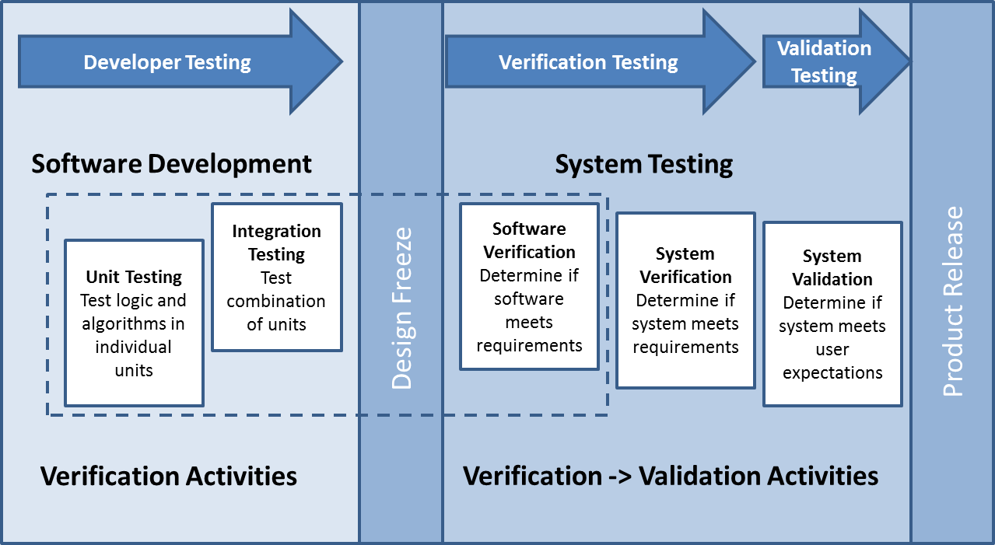

## Architectural design of Reference App

Please find the attached Refernce App architectural diagram

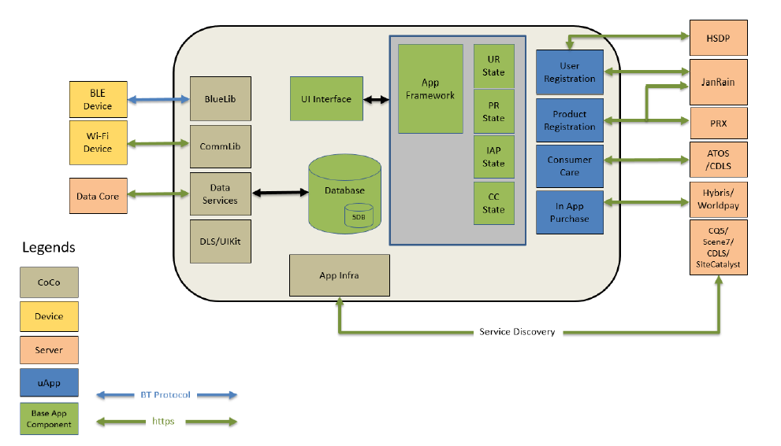

## 1.4 Design flow for Reference App

Refer - AF_Design_Specification_PI5S2_v014.pd

## Feature testing

This section details about the testing strategy for feature, subsystem and integration testing of Reference App module

### Test case design

Below UI work flow diagram of the Reference App shows all common componenets integrated.

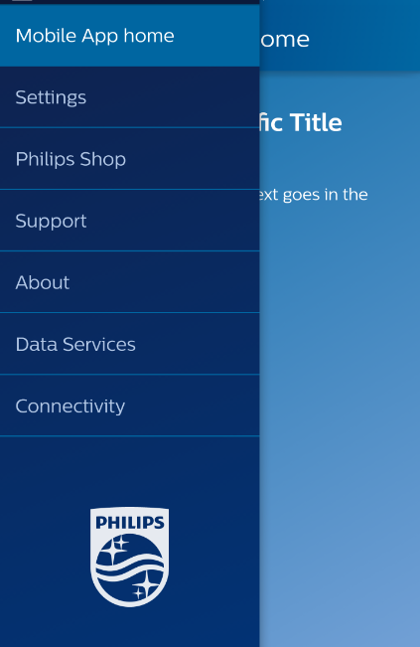

**Why**

* Here we have multiple common components integrated in reference app as shown above in hamburger list, All componenets should be tested with respect to integration with reference app.

### Test device matrix

Backward compatibility test approach is in place which clear says about what devices to be used to test each sprint deliverables. Same is attached below



Along with this whenever a new OS is released OS Compatibly test is performed, for this separate test suite prepared by selecting few cases from each feature.

## References

AF_Design_Specification_PI5S2_v014.pdf

BaseAppArchitecture.pdf

## Terminology & Abbreviations

List of specific definitions and abbreviations used in this document:

|  |  |
| --- | --- |
| **Term** | **Explanation** |
| App | Application |
| BLR | Bangalore |
| CDP | Connected Digital Proposition |
| EHV | Eindhoven |
| EOL | End Of Life |
| GUI | Graphical User Interface |
| HW | Hardware |
| PIC | Philips Innovation Campus |
| POC | Point of Contact |
| RTM | Requirements Traceability Matrix |
| SDK | Software Development Kit |
| SW | Software |
| UI | User Interface |

# Test Method

All test cases as mentioned in Chapter 6 Test Cases shall be executed. The test cases are defined in TFS under

<http://tfsemea1.ta.philips.com:8080/tfs/TPC_Region24/CDP2/TEAM%20Galileo/_testManagement?_a=tests&planId=558&suiteId=14692>

# Sampling Method

N/A

# Test Set-up

Testing on STAGING Environment, iPhone x.x and Android devices and tablet, Verifies all the common components with respect to integration.

# Test Conditions

N/A

# Test Cases

Please refere the attached test cases



# Test Instructions

NA

## Test Case repository

Test case are developed and managed under are managed under TFS tool.

Please refer to below link for accessing the test cases.

<http://tfsemea1.ta.philips.com:8080/tfs/TPC_Region24/CDP2/CDP2%20Platform/_testManagement?planId=558&suiteId=745&_a=tests>

## Test Report

Different test reports are prepared based on the type of testing

* Sanity test report
* Regression test report
* User acceptance test report
* Feature test report
* Weekly review test status report
* Engineering drop testing

Format of these test reports to be finalized

## Quality Metrics/KPI’s

Refer Supplement A – DI Strategy, section 7.2

(Deviation from strategy needs to be discussed and finalized)

# Revision History

| **Version** | **Date** | **Author** | **Description of Change** | **Reason for Change** |
| --- | --- | --- | --- | --- |
| 1.0 | 2017-FEB-15 | Rama & Prabhu | Initial | Needed updates to final version for PI17.1 |
| 1.1 | 2017-March-22 | Ramachandra R | Rework | Additional review comments received |

# Approval

| **Name** | **Role / Function** | **Date** (YYYY-MON-DD) | **Signature** |
| --- | --- | --- | --- |
| Amit Mohanty | Test Architect | 2017-Mar-22 |  |
|  |  |  |  |